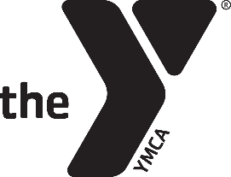
YMCA Camp Immokalee
Halloween Camp 2019
Counselor-in-Training (CIT) Application

Please complete this form and return it to Allison Vining at
avining@fcymca.org by October 11, 2019.

Please Note: The cost of Halloween Camp is $110 (includes t-shirt).
CIT Information
Name: ________________________________________ Age: ________ Grade: __________
Phone Number: ___________________________ Email Address: ___________________________________
T-Shirt Size: AS AM AL AXL AXXL AXXL
Parent Information
Name: ________________________________________ Relation to Applicant: _______________________
Phone Number: ___________________________ Email Address: ___________________________________
List any school involvement (clubs, sports, leadership, etc.).

List any camper/CIT involvement along with number of years and name of camp.

- Why do you want to serve as a CIT during Halloween Camp?

- What do you think you can bring to the CIT program?

- How is being a CIT different from being a camper?

- What else do you want us to know about you?

___________________________________________________________________________________ ___________________
CIT Signature Date

___________________________________________________________________________________ ___________________
Parent Signature Date

